| **Final Group Project Assignment** | |
| --- | --- |
| Project Detail | Final Strategy Proposal for OnePlus |
| Stakeholder / Company | OnePlus |
| Subject | MASY1-GC 1230 |
| Adjunct Instructor | J. Terry McCarthy |
| Team Members | Shreya Shreya Fengrong Xing  Saumay Killa Yuyang Liu Sejal Khadkikar |

1. **Introduction :**

OnePlus is a Chinese smartphone manufacturer known for producing high-quality smartphones with a focus on delivering a premium user experience. The company was founded in December 2013 by Pete Lau and Carl Pei, headquartered in [Shenzhen](https://en.wikipedia.org/wiki/Shenzhen), [Guangdong](https://en.wikipedia.org/wiki/Guangdong), China. Oneplus mainly deals in products such as smartphones, earphones, power banks, OxygenOS, phone cases, televisions, and smartwatches.

OnePlus gained a reputation for its "NEVER SETTLE" philosophy, emphasizing a commitment to delivering top-notch performance and cutting-edge technology.

1. **Existing Marketing Strategy:**

**1+4+X:**

1

One smartphone model offering all flagship-killer specifications at an affordable price,the OnePlus 11 will set you back $699 (US) for 8GB RAM and 128GB storage and $799 for 16GB RAM and 256GB storage.

4

Four surrounding ecosystem on products, including TWS, TV, smartwatch and tablet devices that will connect together

X

Represents products that will connect with the OnePlus ecosystem, such as keyboards.

Flagship Killer Positioning:

OnePlus is only offering one flagship model that has all the features a premium device should have.OnePlus has positioned its smartphones as 'flagship killers,' offering premium features and performance at more affordable prices compared to other high-end devices. This positioning is central to their marketing message.

Community-Centric Approach:

OnePlus has successfully fostered a vibrant community around its brand by actively engaging with users through forums, events, and feedback sessions. By involving the community in product development and decision-making processes, they create a strong sense of belonging and loyalty.

Online Sales Model:

OnePlus initially adopted a direct-to-consumer online sales model, exclusively selling its smartphones through its website. This approach proved beneficial in cost control and maintaining a direct relationship with customers.

Limited Edition Releases:

OnePlus occasionally releases limited edition or special variants of its smartphones, which not only creates a sense of exclusivity but also encourages fans to purchase the latest models in order to enjoy unique features or designs.

Social Media Presence:

OnePlus has a strong presence on various social media platforms, particularly Twitter, Instagram, and YouTube. They utilize these channels to create excitement about upcoming products, share inspiring user testimonials, and actively interact with their audience. Interconnecting with its audience from social media and promoting itself on some of the series on Netflix helps

Innovative Launch Events:

OnePlus is renowned for its innovative and captivating product launch events. These highly anticipated occasions often feature live streams, collaborations with influential individuals, and distinctive presentations to create excitement and generate extensive media coverage.

Partnerships and Collaborations:

OnePlus has collaborated with various brands and entities to create exclusive editions of its devices. For instance, partnerships with renowned companies like McLaren have resulted in the creation of special OnePlus McLaren Edition smartphones.

Continuous Innovation and Product Iteration:

OnePlus is renowned for its unwavering dedication to continuous innovation and regular product releases. The company consistently updates its product lineup to incorporate cutting-edge technology and meet the ever-evolving expectations of consumers.

1. **Major Competitors**

* Samsung : Their Galaxy S and Note series are often seen as direct competitors to OnePlus's high-end models due to their cutting-edge technology and premium features.
* Xiaomi : Their MI and Redmi series compete with OnePlus in terms of offering high-quality specifications at lower prices, specially in asian market
* Apple : With its strong brand loyalty, ecosystem integration, and emphasis on user experience and design, apple competes for the same premium market segment as OnePlus.

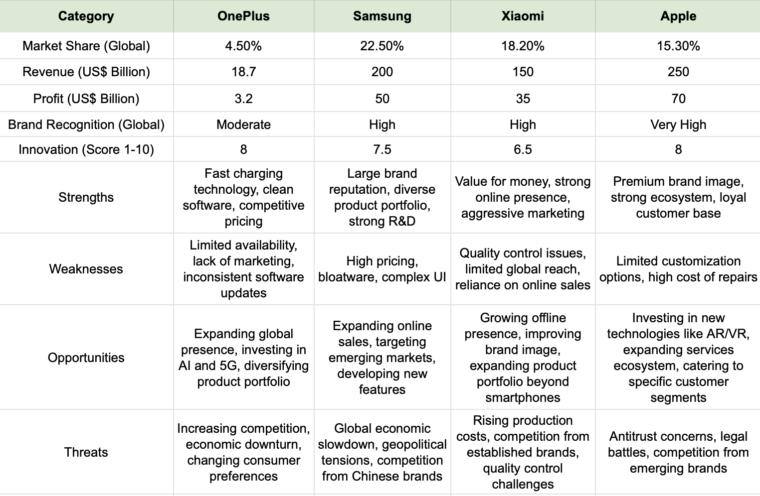

OnePlus faces stiff competition in the smartphone market, with Samsung, Xiaomi, and Apple holding significantly larger market shares and revenue. While OnePlus boasts strengths in fast charging, clean software, and competitive pricing, it struggles with limited availability, inconsistent software updates, and lack of marketing power. To stay ahead, OnePlus needs to expand its global presence, invest in new technologies like AI and 5G, and diversify its product portfolio. However, it faces threats from economic downturns, changing consumer preferences, and increasing competition from established and emerging brands. Success will depend on its ability to overcome these challenges while leveraging its unique strengths to carve out a larger share of the global smartphone market.

1. **SWOT Analysis**

**Strength :**

i) Focus on High-Quality Products: OnePlus has always focused on providing high-quality devices that rival the performance and features of much pricier flagship devices from other manufacturers. This commitment to quality has helped them build a solid reputation in the market.

ii) Cost-Effective Devices: While providing high-quality products, OnePlus maintains competitive pricing, often significantly lower than flagship devices from brands like Samsung and Apple. This makes their devices more accessible to a larger audience looking for premium devices at a reasonable price.

iii) Strong Online Presence and Marketing: OnePlus effectively leverages digital marketing and social media to engage with its customers. Their marketing campaigns often generate a lot of buzz in the tech community, which aids in product promotion and brand recognition.

iv) Customer-First Approach: OnePlus has developed a loyal customer base due to its customer-centric approach. The company maintains open channels for customer feedback and regularly updates its software based on user recommendations.

v) Rapid Technological Advancements: OnePlus is known for adopting the latest technologies quickly. For instance, they were among the first to introduce smartphones with high-refresh-rate screens. This helps them stay competitive and meet the evolving needs of their customers.

**Weakness :**

i) Limited Offline Presence: OnePlus primarily sells its products online, which limits its reach to customers who prefer to purchase in brick-and-mortar stores. Expanding its offline distribution could be challenging, especially in markets where traditional retail remains strong.

ii) Product Portfolio: While OnePlus has expanded beyond smartphones, its portfolio is still limited compared to rivals like Samsung or Apple, which offer diverse products and services.

iii) Brand Perception: Although OnePlus smartphones are often considered high-quality, the brand doesn’t yet have the same prestige as other tech giants like Apple or Samsung. This can limit its appeal among consumers who consider brand status an important factor in purchasing decisions.

iv) Market Dependence: OnePlus is highly dependent on certain markets like India and China for a majority of its sales. This makes it vulnerable to economic and regulatory changes in these regions.

v) Post-Sales Service: OnePlus has sometimes faced criticism regarding its after-sales service. Although the company is working to improve this, more efforts might be required to match the service levels of other established players in the market.

**Opportunities :**

i) Expand Offline Presence: Expanding its offline retail presence, especially in markets where brick-and-mortar stores still play a crucial role, could allow OnePlus to reach a broader customer base.

ii) Diversify Product Portfolio: OnePlus can venture into new product categories and diversify its product portfolio. For instance, the wearable tech industry, smart home devices, and other IoT-based products present promising growth opportunities.

iii) Extend Services: Along with hardware, OnePlus can look into expanding its service-based offerings. This could include things like a dedicated app store, cloud services, streaming services, and even financial services like many of its competitors have done.

iv) Market Expansion: There’s potential for OnePlus to expand further into other geographical markets. Many emerging markets have growing middle-class populations that are increasingly tech-savvy and value the mix of quality and affordability that OnePlus offers.

v) Partnerships and Collaborations: OnePlus can explore strategic partnerships and collaborations with other tech firms to introduce new features and services. This might involve partnering with gaming companies, streaming services, or other tech sectors where OnePlus does not currently have a presence.

**Threat :**

i) Intense Competition: The smartphone industry is intensely competitive, with major players such as Apple, Samsung, and other emerging Chinese smartphone manufacturers continually innovating and launching new products. This puts constant pressure on OnePlus to maintain its pace of innovation and product offering.

ii) Dependence on Android: OnePlus’ reliance on the Android operating system could be a threat. Any significant changes in Google’s policies, pricing, or access to the Android operating system could impact OnePlus’s operations.

iii) Rising Production Costs: With rising manufacturing costs and increasing prices of raw materials, OnePlus may face the challenge of maintaining its current pricing strategy. This could affect the company’s profitability and competitive edge.

iv) Global Economic and Political Factors: OnePlus operates in a global market, making it susceptible to various geopolitical risks, changes in trade policies, currency fluctuation, and other factors that could affect its business.

v)Brand Perception: While OnePlus has successfully established itself as a premium smartphone brand, maintaining this image is a constant challenge, especially given the intense competition in this sector.

1. **Strategy in context of Flywheel :**

The key to the flywheel model's effectiveness is the compounding effect of these interconnected components. Each element not only contributes to growth but is also enhanced by it, creating a virtuous cycle that can be difficult for competitors to disrupt

Using the flywheel framework, OnePlus can create a strategic marketing plan that harnesses each component's momentum to propel the brand forward. Here are some ideas tailored to each segment of the flywheel:

1. Customer Experience:

1. VIP Customer Program: Launch an exclusive membership program that rewards loyal customers with early access to new releases, exclusive discounts, and premium support.
2. User-Centric Design: Involve the community in the design and feature selection for new models through surveys and beta testing programs.

2. Traffic:

1. Referral Programs: Implement a referral program that incentivizes current users to bring in new customers by offering them benefits such as discounts on future purchases or exclusive OnePlus merchandise.
2. Influencer Partnerships: Collaborate with tech influencers and enthusiasts to create buzz around product launches and drive traffic to OnePlus websites and stores.

3. Sellers:

1. Partnerships with Carriers and Retailers: Expand availability through strategic partnerships with more carriers, electronics retailers, and online marketplaces.
2. Co-branding Opportunities: Partner with other tech brands to create bundled offerings, enhancing the appeal to potential sellers and customers.

4. Selection:

1. Diversify Product Line: Introduce a wider range of products, such as entry-level phones, wearables, and lifestyle accessories, to cater to different market segments.
2. Limited Edition Releases: Occasionally release special edition phones in collaboration with artists, designers, or popular franchises to create buzz and broaden appeal.

5. Lower Prices:

1. Economies of Scale: Leverage increased production volumes to negotiate better component pricing, passing on some of the cost savings to consumers.
2. Dynamic Pricing Models: Introduce competitive pricing strategies that adjust based on market trends and consumer demand, potentially under a sub-brand.

6. Improved Efficiency:

1. Invest in Logistics: Develop a more robust logistics network to ensure faster delivery times and improved customer satisfaction.
2. Streamline Operations: Use data analytics to streamline operations and reduce waste, leading to cost savings that can be invested back into the business or passed on to customers.

7. Infrastructure Investment:

1. R&D Investment: Allocate more resources to research and development, particularly in areas like battery technology, camera improvements, and software optimizations.
2. Customer Service Expansion: Invest in expanding and training the customer service team to provide exceptional support, fostering brand loyalty.

8. Growth:

1. Market Expansion: Identify and enter new geographical markets with targeted marketing campaigns that cater to local preferences and cultural nuances.
2. Brand Advocacy: Cultivate a community of OnePlus advocates through exclusive community events, online forums, and participation in social causes.

By focusing on these strategic areas, OnePlus can create a self-sustaining marketing flywheel that generates growth through improved customer experience, increased traffic, and an expanded selection of products, all while maintaining competitive prices and investing in the infrastructure needed to support long-term growth. This approach not only addresses the immediate need to stand out in a crowded market but also builds the foundation for sustainable success.

1. **Our pivotal strategy :**

Our pivotal strategy is to expand in the South American markets. OnePlus, a prominent smartphone brand, could consider expanding into South American markets for several strategic reasons:

1. Untapped Market Potential: South America, with its diverse and growing population, presents a significant opportunity for market expansion. The region has a large consumer base that is increasingly tech-savvy and interested in smartphones.
2. Growing Smartphone Penetration: South America has seen a steady increase in smartphone usage and internet penetration. Expanding into this market would allow OnePlus to tap into a growing base of digital consumers.
3. Diversification of Revenue Streams: Expanding into new markets like South America helps diversify revenue streams. This is beneficial for risk management, as it reduces reliance on existing markets.
4. Competitive Presence: Many global smartphone brands are already established or expanding in South American countries. OnePlus entering this market would allow it to compete directly with these brands and capture market share.
5. Brand Recognition and Global Presence: Establishing a presence in South America could enhance OnePlus’s brand recognition and global footprint, contributing to its image as a worldwide player in the smartphone industry.
6. Adapting to Local Needs: By entering the South American market, OnePlus can adapt its products to meet local preferences and requirements, potentially leading to unique product offerings that resonate with the local populace.
7. Economic Growth in the Region: Some South American countries are experiencing economic growth, increasing the purchasing power of consumers. This makes it a potentially lucrative market for premium smartphone brands like OnePlus.
8. Partnerships and Alliances: Entry into South America could open avenues for partnerships with local telecom providers and retailers, aiding in effective market penetration and distribution.

Overall, OnePlus's expansion into South America could be a strategic move to capitalize on emerging market opportunities, increase global brand presence, and diversify its market portfolio.

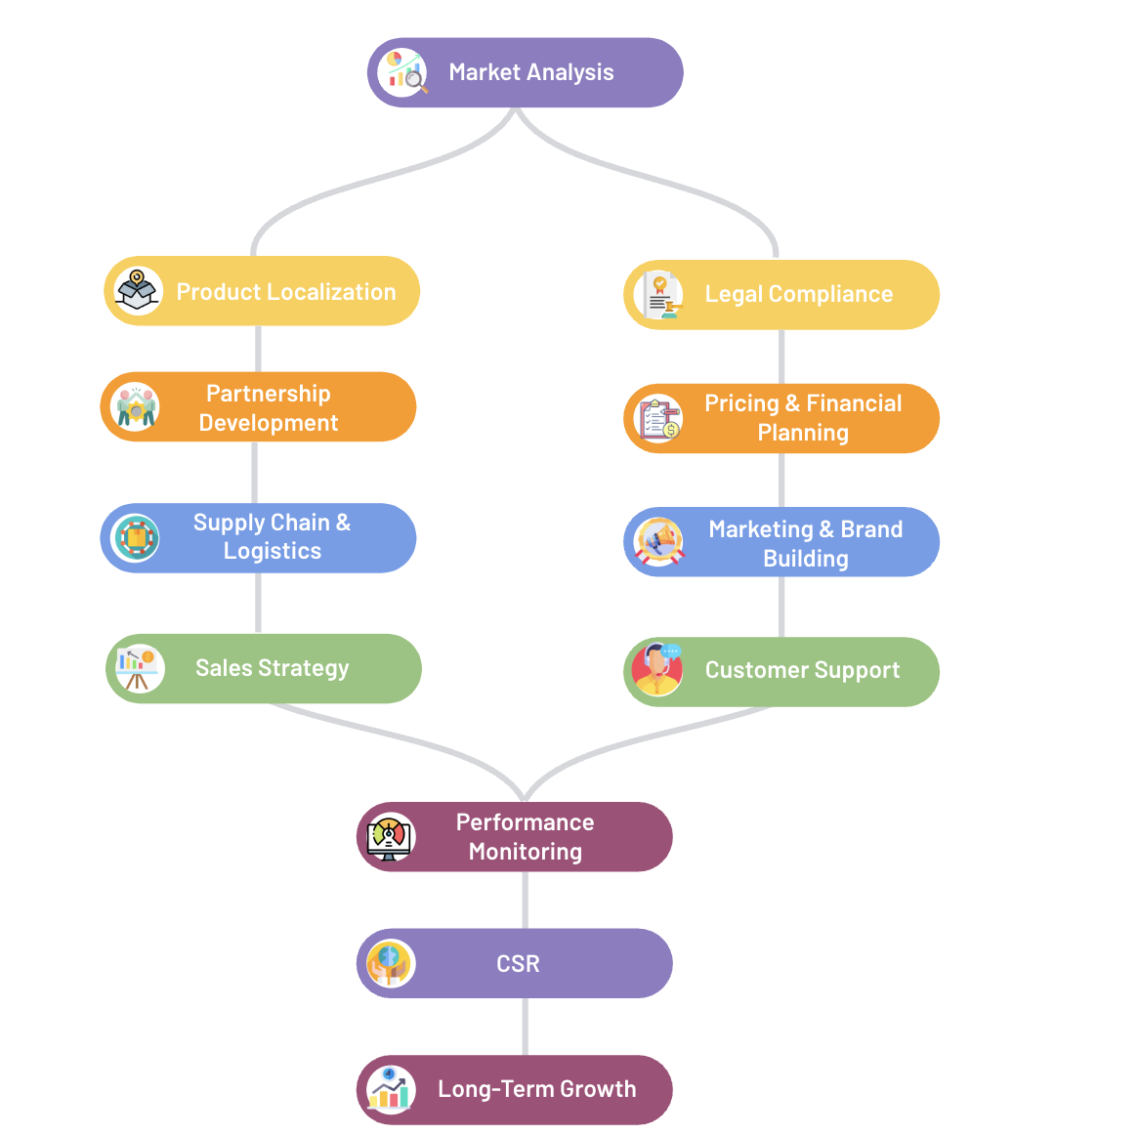

This flowchart visually represents the strategic plan for OnePlus's expansion into the South American market. Each node represents a key step in the strategy, and the arrows show the flow and connections between these steps.

Here's a breakdown of the flowchart:

1. Market Analysis: This is the starting point of the expansion strategy. Here, OnePlus would conduct thorough research to understand the South American market, including consumer preferences, competitor analysis, and market trends.
2. Product Localization: Based on insights from the market analysis, OnePlus would adapt its products to meet local needs. This could include language localization, adjusting technical specifications, or incorporating region-specific features.
3. Legal Compliance: Simultaneously, OnePlus would need to ensure compliance with local laws and regulations in South American countries. This includes import laws, business regulations, and certification requirements.
4. Partnership Development: From the product localization stage, OnePlus would move on to establish partnerships with local distributors, retailers, and telecom operators. These partnerships are crucial for effective distribution and market penetration.
5. Pricing & Financial Planning: In parallel with developing partnerships, OnePlus would also need to set competitive pricing strategies and plan its financials, considering local market conditions and costs.
6. Supply Chain & Logistics: Once partnerships are in place and pricing strategies are determined, setting up a supply chain and logistics network is crucial. This involves establishing warehouses, distribution networks, and logistics partnerships.
7. Marketing & Brand Building: With the supply chain set up, the focus shifts to marketing and brand building. OnePlus would initiate marketing campaigns, including digital and traditional media, to build brand awareness and presence in the market.
8. Sales Strategy: Concurrent with marketing efforts, sales strategies are implemented. This could involve online and offline sales channels, including e-commerce platforms and physical retail stores.
9. Customer Support: As sales commence, establishing strong customer support, including after-sales services and call centers, is vital for customer satisfaction and brand loyalty.
10. Performance Monitoring: Once the market entry is underway, OnePlus would continuously monitor its performance. This includes sales tracking, customer feedback, and market trends to make necessary strategy adjustments.
11. CSR (Corporate Social Responsibility): Engaging in CSR activities helps in building a positive brand image and giving back to the community. This might include environmental initiatives, community programs, or technology education projects.
12. Long-term Growth: The final stage focuses on long-term growth and expansion. Based on the market performance, OnePlus would plan for future expansion, product diversification, and other strategic initiatives in the region.

Overall, this flowchart outlines a comprehensive and sequential approach for OnePlus to successfully enter and grow in the South American smartphone market.

1. **Finance**

I first analyzed One Plus through Google Trends to analyze its popularity in the United States, China and India in the past seven years. Basically, during the release stage every year, their popularity will increase relatively. We can clearly feel that its popularity has begun to enter a very gentle stage after 2021, especially in China, which has begun to show a downward trend. The merger with OPPO is the main reason for this problem, because they started to merge in 2021.

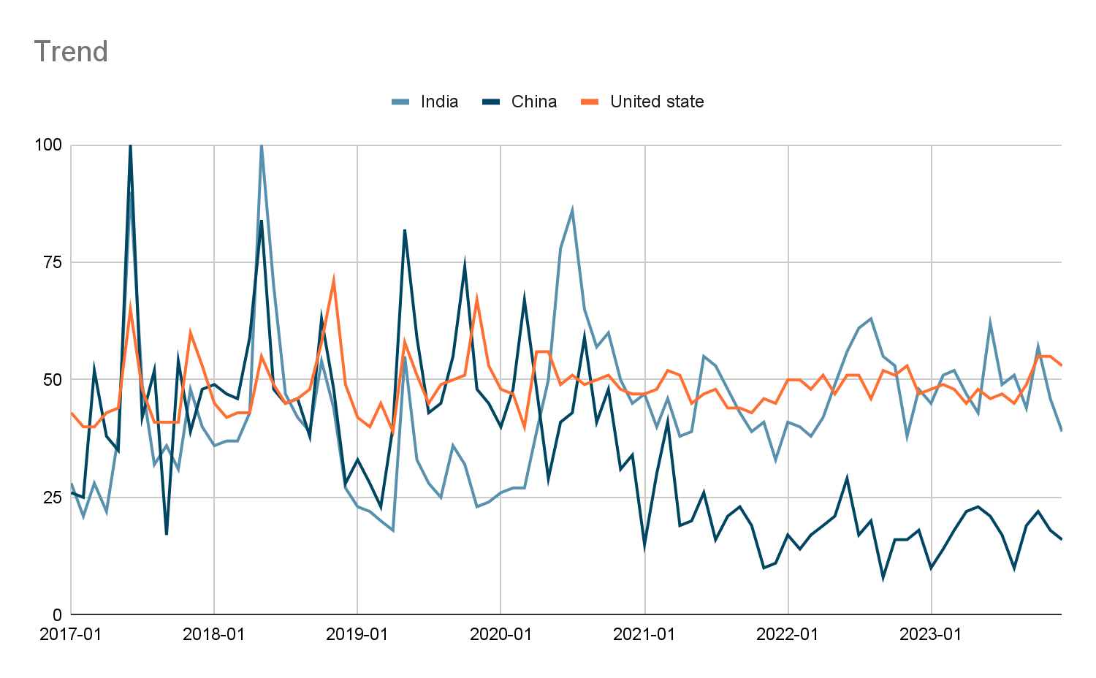

In the subsequent analysis of revenue, one plus did not give a very formal financial statement, but they may share some of their milestones this year with their community. We can use this information to predict their specific revenue. Although the result will not be completely accurate, we can be sure that their revenue is on an upward trend.

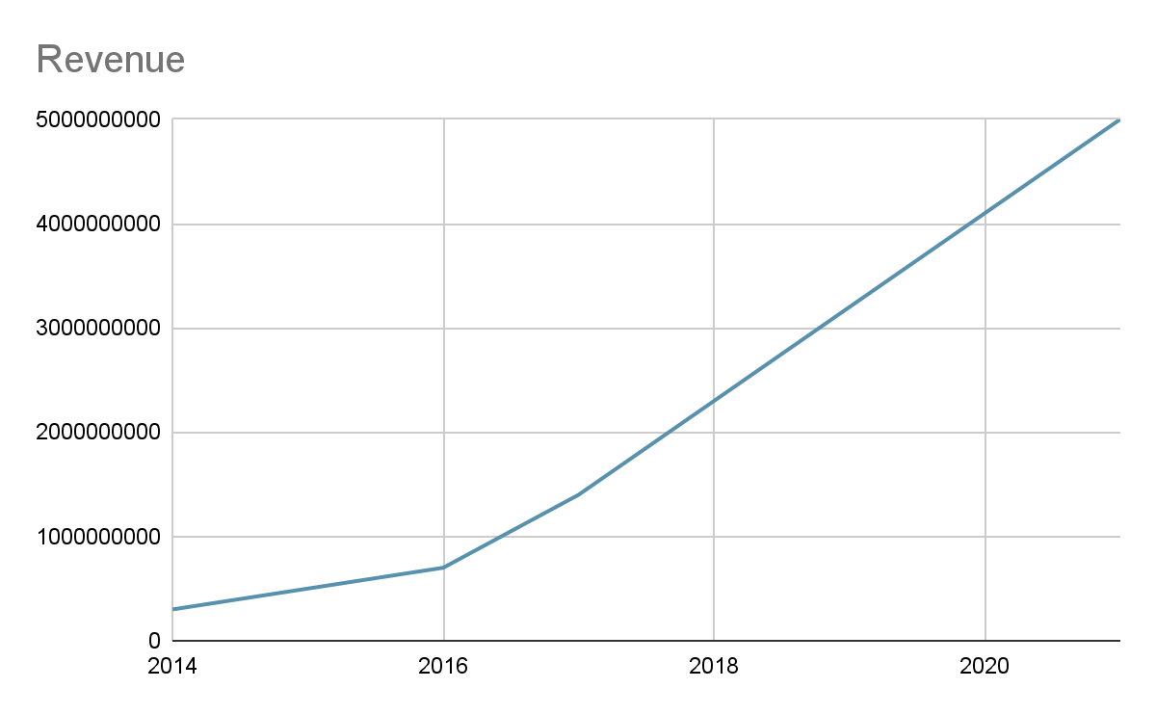

These three websites give this information

<https://community.oneplus.com/thread/259829>

<https://www.oneplus.com/us/annual-report-2017>

<https://community.oneplus.com/thread/1549522>

our predictions

One Plus's own forecast is that the number of Red Cable Club memberships will rise from 20 million in 2021 and exceed 30 million in 2022. This is an increase of about 50%, but due to the merger with oppo in 2021, the reputation and popularity of One Plus have declined. So their revenue from 2021 to 2023 didn’t have great changes. But by combining it with these strategies that we've come up with. We believe that one plus can have 15%-30% annual growth space in the future.

